**14. Try Static NAT, Dynamic NAT, and PAT to translate IPs.**

* Static NAT: One-to-one mapping. Useful for servers or devices needing consistent public IPs.
* Dynamic NAT: Maps private IPs to a pool of public IPs. Useful for a limited number of public IPs.
* PAT: Maps multiple private IPs to a single public IP, using port numbers to differentiate. Most commonly used for home and small office networks.

**Network Setup:**

* Built a network with inside (private) and outside (public) networks.
* Assigned IP addresses to PCs, Router interfaces, and Server.

**Basic Router Configuration:**

* Enabled router interfaces.
* Set default route on the router.

**Static NAT:**

* Mapped PC0's private IP to a specific public IP.
* Designated inside and outside interfaces.
* Tested by pinging the public IP from the Server.

**Dynamic NAT:**

* Created a pool of public IPs.
* Created an access list to define which internal traffic would be translated.
* Mapped the inside network to the IP pool.
* Tested by pinging the Server from PC1.

**PAT:**

* Overloaded the Router's outside interface IP for all inside devices.
* Tested by pinging the Server from both PCs, verifying the source IP and differing source ports.

**Setting Up:**

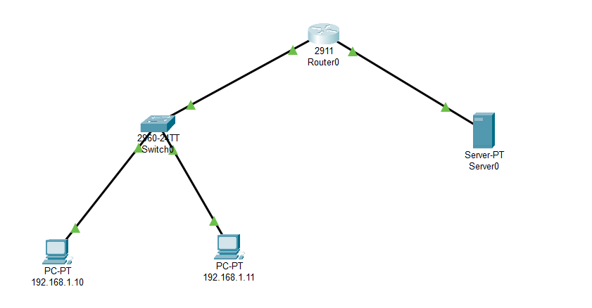

**Static NAT Configuration for PC0:**

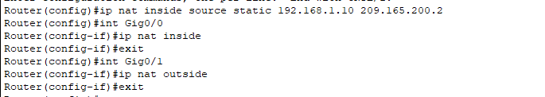

**As a result of Static NAT the server can ping PC0:**

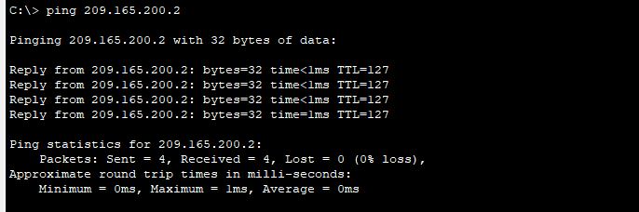

**Dynamic NAT Configuration for PC1:**



**As a result of Dynamic NAT, PC1 can ping the server:**

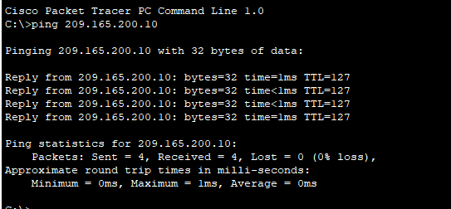

**PAT (Port Address Translation):**



**As a result of PAT:**

**Both PCs appear to have the source IP 209.165.200.1, but with different source ports.**